This is a how to for mass updating of items, for example if there are items that need to be serialized FG to enable serial tracked in the WD
For single item: Go to Product information management, search for the item, and apply the 401SGP Serialized FG template. Then save
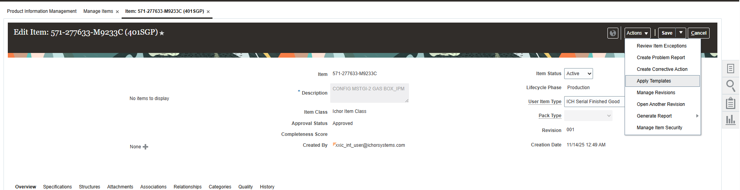
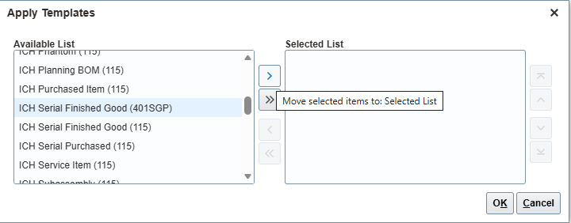

For multiple items: go to manage items. Find a way to display all the items you want refreshed, for example searching for all items starting with 571-277633. Also, ensure that you have the columns listed in the screenshot (edit using the view button)
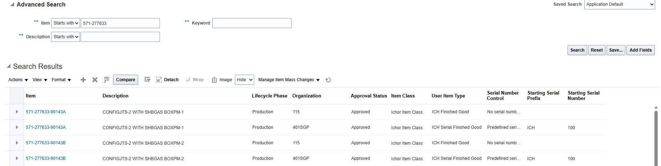

Select the WDs you want to change, click manage item mass changes and edit item attributes in spreadsheet. Download the spreadsheet
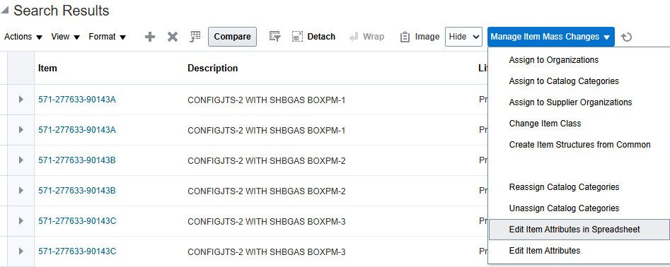

Right click the spreadsheet and check unblock to allow macros.
Edit the tables as you need. For example, you can edit the starting serial prefix as well as starting number to mass update to FGS.
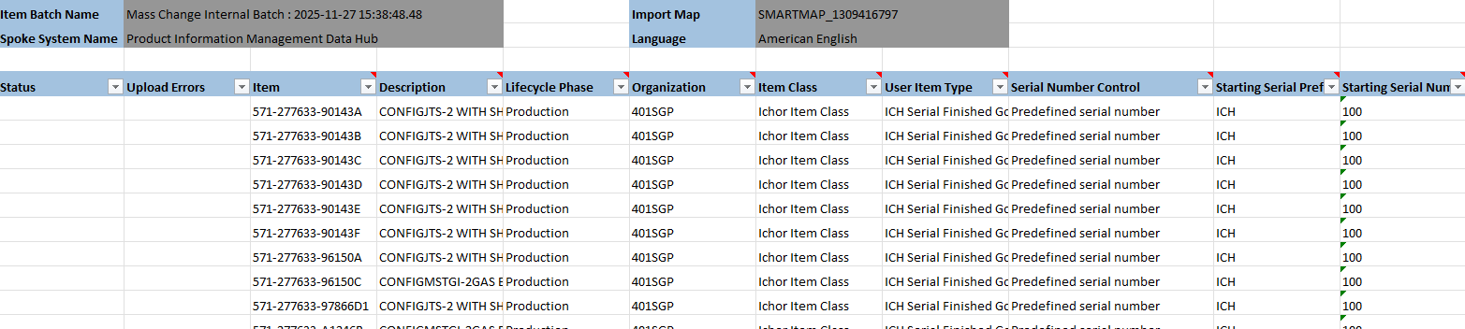
There is an add ins tab at the top, click validate then upload data. Follow the instructions.
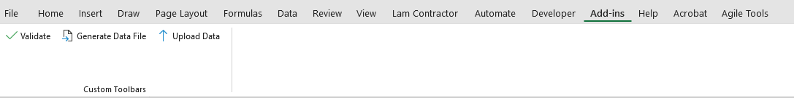

After successful, navigate to scheduled processes and search for item import
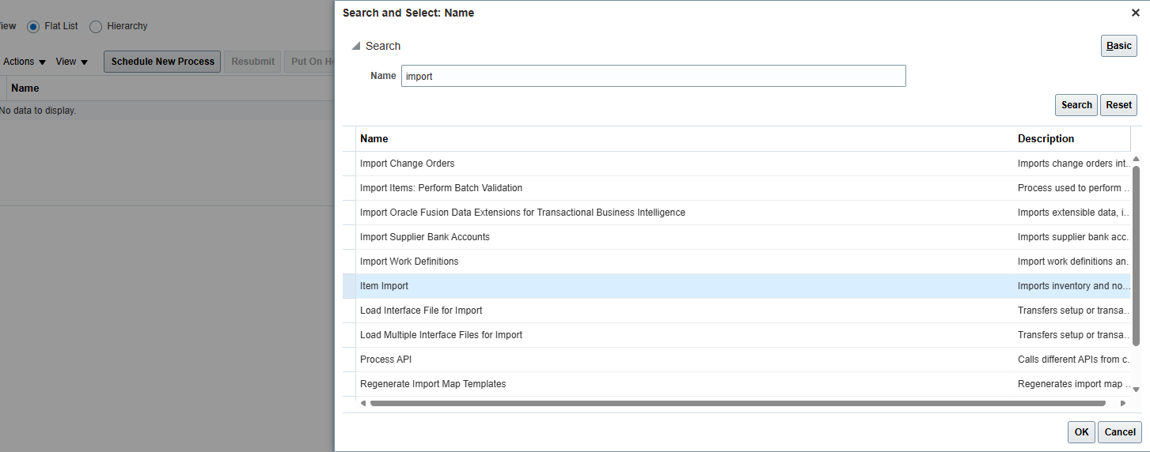
Key in the batch id generated, fill in the blanks like this and submit:
